**Name:** Aditya Raja **ID:** N9062611

**Personal Portfolio**

**Release 1 artefacts:**

1. **Added Acceptance criteria** *(Week 5-6) --- not sure if can add this?*

|  |  |  |
| --- | --- | --- |
| **Task** | **Description** | **Benefit to project** |
| Add Acceptance criteria to user stories | Using the MoSCoW technique, I developed acceptance criteria for student and parent user stories | Having acceptance criteria reduces rework and makes a clear understanding of the tasks at hand. It also improves client acceptance. |

**Evidence (Word Doc):** (Acceptance Criteria.DOCX)

1. **Create database tables** *(Week 6-7)*

|  |  |  |
| --- | --- | --- |
| **Task** | **Description** | **Benefit to project** |
| Create database tables and add values | Using MySQL database, I created tables and added attributes into those tables. These tables were also used to create the ERD diagram and transfer the database to PostgreSQL later on. | Helps save information from the forms to the tables and retrieve information from the tables too. This task also helped to create the ERD diagram which was beneficial for the understanding of the database |

**Evidence (Database tables and values screenshot):**  
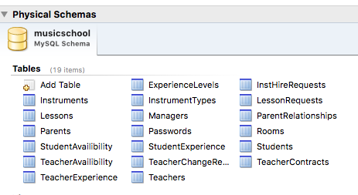

**Evidence (MySQL File):** (musicschool-1.mwb)

1. **Learn Node.Js** *(Week 8-9)*

|  |  |  |
| --- | --- | --- |
| **Task** | **Description** | **Benefit to project** |
| Learn and understand Node.Js | Our team was using node.js for the backend tasks and needed more help on the backend tasks and asked me to learn it. | Since node.js is only a framework and not a programming language, I managed to understand some aspects of it and this resulted in me being able to help in smaller tasks around the project. |

Evidence (Validation code):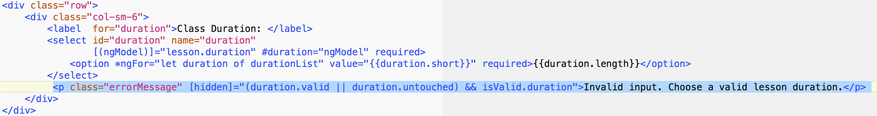

1. **Form designing** *(Week 8)*

|  |  |  |
| --- | --- | --- |
| **Task** | **Description** | **Benefit to project** |
| Redesigning the application form designs | In order to make the design of the website more user friendly and intuitive, I was responsible for making the forms look better. | Starting with the student application form, the design was later added to the other forms. The new forms help stagnate a user friendly design and improved the clients liking of the product. |

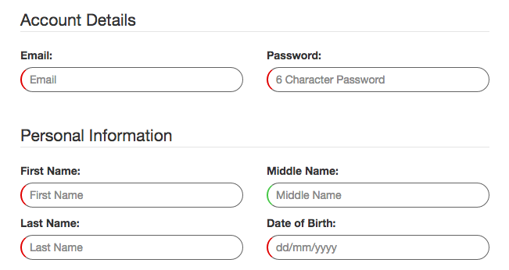**Evidence (Code /screenshots):**

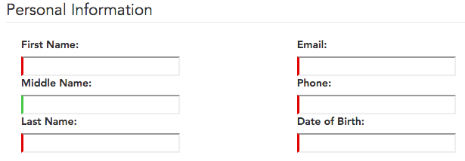

**New Design:**

**Old Design:**

1. **Redesign button and add hover** *(Week 8)*

|  |  |  |
| --- | --- | --- |
| **Task** | **Description** | **Benefit to project** |
| Redesigning the submit button and adding a hover to it | In order to make the form more intuitive, I was also responsible for changing the button design to make it look more streamlined. Apart from this I also added a hover option, which worked only when the form passed the validations and was ready to submit | The design helped increase system usability. The button design was later added to the other forms and further changed in the future sprints.  *(This design was changed later on again in release 2)* |

**Evidence (Screenshot):**



**Hover Effect:**

**Old Design:**

**New Design:**

**Release 2 artefacts:**

1. **Add lesson length** *(Week 11)*

|  |  |  |
| --- | --- | --- |
| **Task** | **Description** | **Benefit to project** |
| Adding an option to choose lesson length (including validation) | While applying for lessons, students have the option to choose a specific lesson length which they prefer. The default option was 1 hour; However, I have added another option of 30 mins as per the client’s request. | Being one of the small features that make up a larger feature, it is important to have such features working in the process. This feature improves and adds variety to the overall class applications. |

**Evidence (Code/screenshots):**

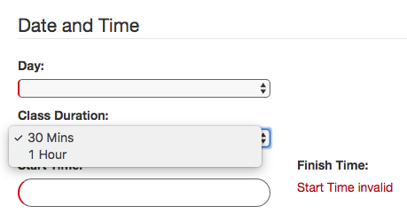

**Lesson durations:**

**Code:**

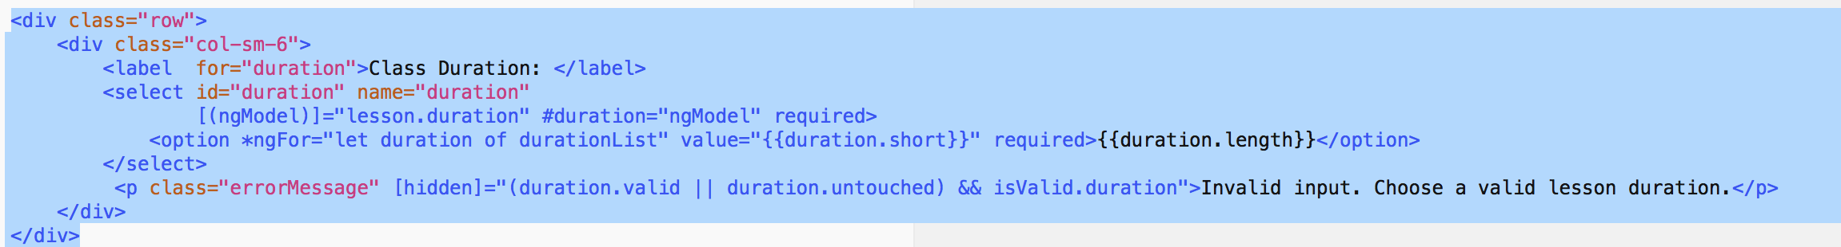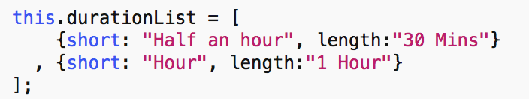

**Selection List:**

1. **Presentation notes** *(Week 11)*

|  |  |  |
| --- | --- | --- |
| **Task** | **Description** | **Benefit to project** |
| Making presentation notes | Taking notes of important points and areas of feedback for the business letter. | Taking notes during the week 11 demonstration from the development team, benefited us when making the business letter. It helped create some positives and negatives that were highlighted to them in the feedback provided to them. |

**Evidence (Word Doc):** (Presentation Notes.DOCX)

1. **Test account validation to accept student applications** *(Week 12)*

|  |  |  |
| --- | --- | --- |
| **Task** | **Description** | **Benefit to project** |
| Test accepting student applications | Students have the option of picking a specific teacher or let any teacher choose them. The specific teacher chosen needs to be able to accept the student. However, if a specific teacher declines the student other teachers should be able to accept the application. However, accepting a student should only be visible to teachers and not to other staff/managers. | This is one of the major requirements of the project. Hence, a successful testing and working of the feature is needed to gain the clients approval of this feature. |

**Evidence (Manual test script):** (Accepting Student Applications Test Log.XLSX)

1. **Test reactivating teacher accounts** *(Week 13)*

|  |  |  |
| --- | --- | --- |
| **Task** | **Description** | **Benefit to project** |
| Test reactivating teacher accounts | Teacher accounts can be deactivated, by the manager in case the teacher is no longer working at the music school. However, the manager does have the authority to reactivate these accounts if needed. The process of reactivating teacher accounts needed to be tested. | By completing the successful manual testing, I had reduced the workload off other members. It also helped improve system reliability and ensured that the feature is working without any issues. |

**Evidence (Manual test script):** (Reactivating Teacher Accounts Test Log.XLSX)

1. **Test viewing and filtering** *(Week 13)*

|  |  |  |
| --- | --- | --- |
| **Task** | **Description** | **Comments** |
| Test viewing and filtering the instrument list | The manager account is able to view a list of all instruments, new and used. On the view instruments page, we are also able to use the search bar to filter out different instruments based on the search query. The search process needs to be testing using different search options. | Using different combinations in manual testing, I was able to ensure that the search bar is able to successfully filter instruments based of the search requirements. By passing the testing successfully our team knows that we have another working feature to present to the clients. |

**Evidence (Manual test script):** (Viewing and Filtering Instrument List Test Log.XLSX)